Lab Assignment 1.3
K.KRANTHI 1476

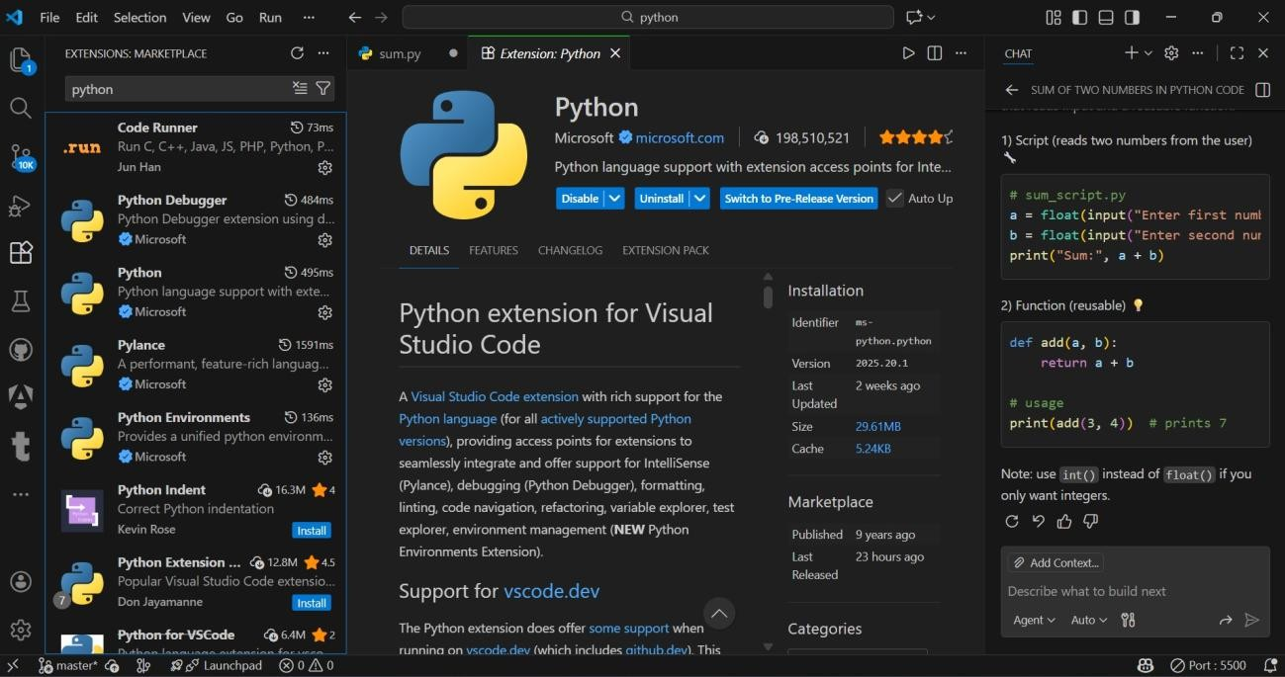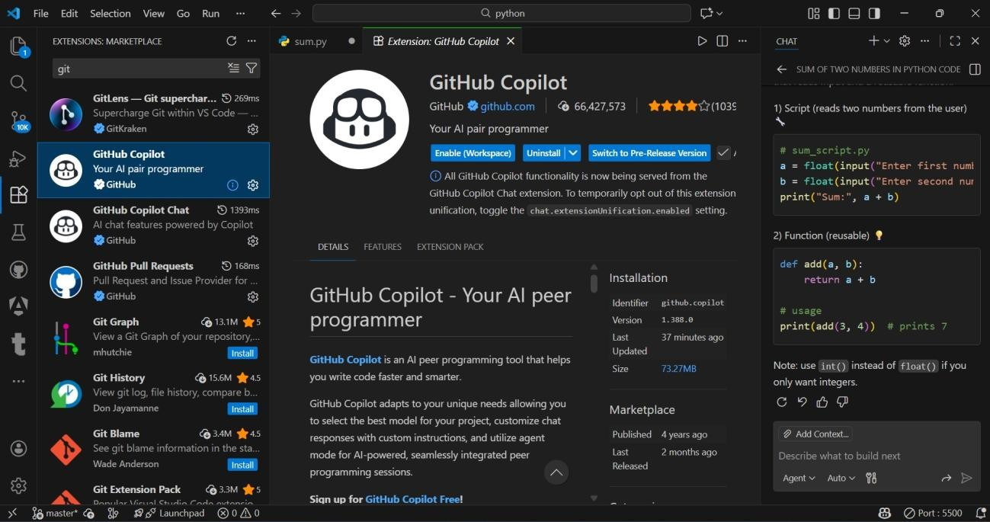
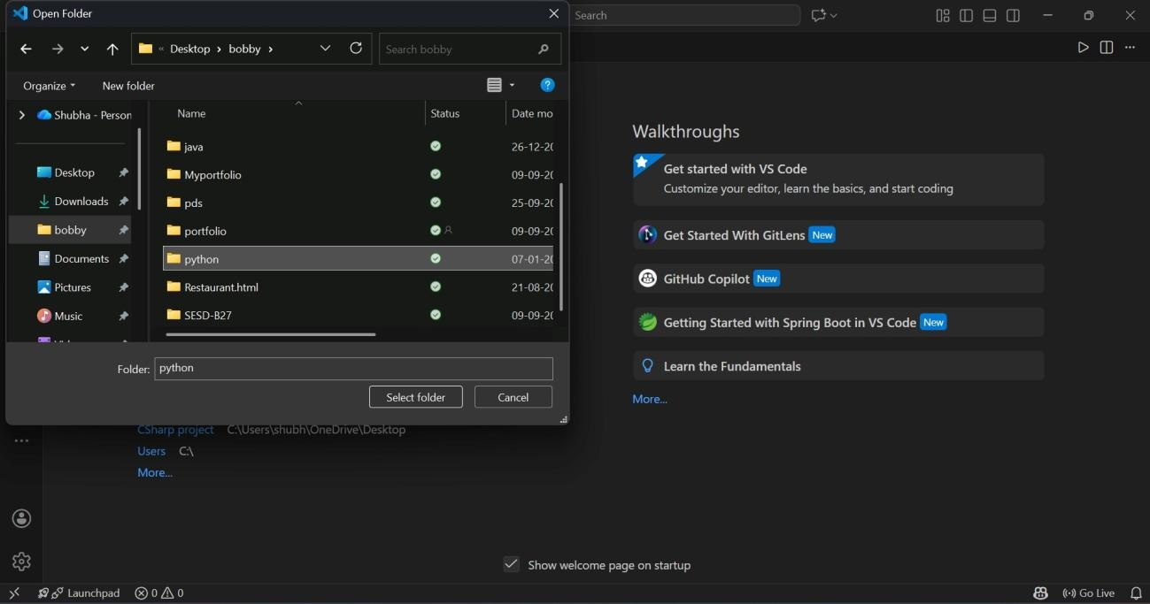

Task 1: AI-Generated Logic Without Modularization (Procedural Fibonacci) :

# Fibonacci sequence

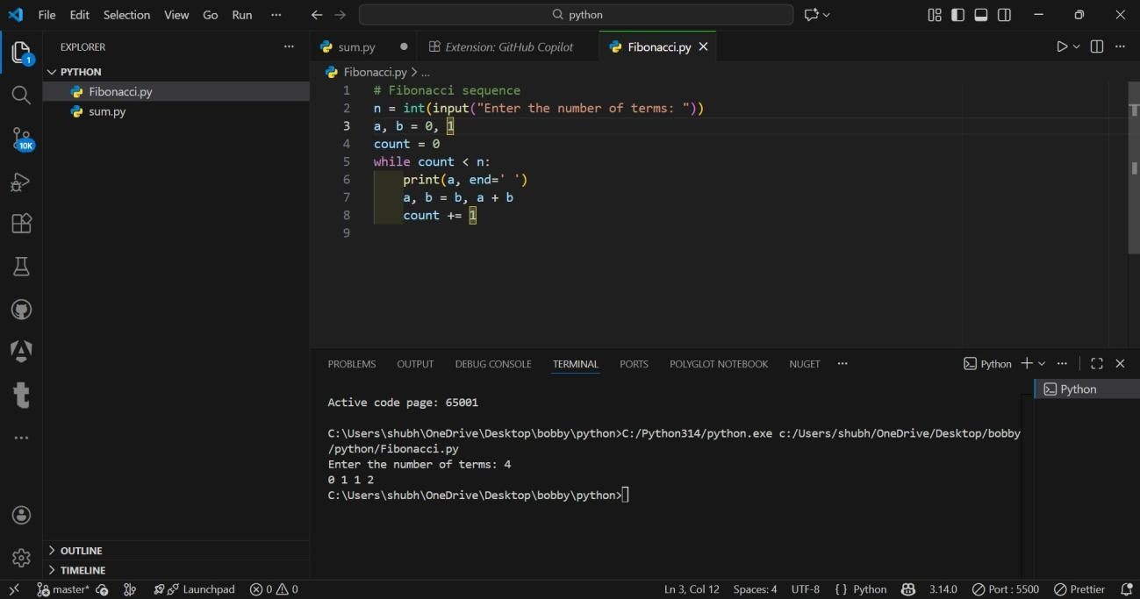

Task 2: AI Code Optimization & Cleanup :
# Optimize this Fibonacci code
# Simplify variable usage
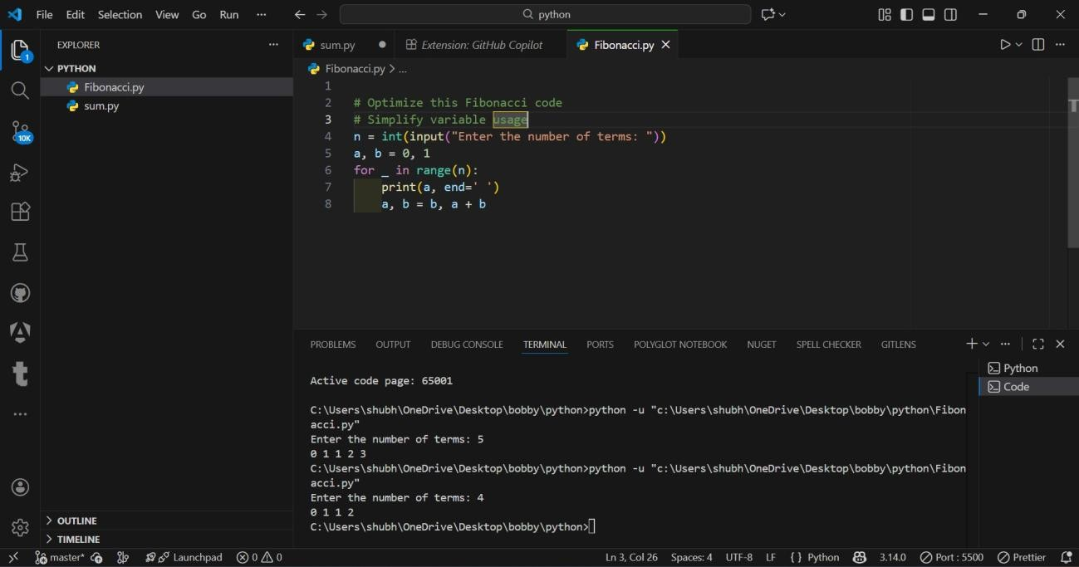
Task 3: Modular Design Using AI Assistance (Function-Based Fibonacci) :

# Write a Python function to generate Fibonacci sequence up to n
# Use meaningful comments

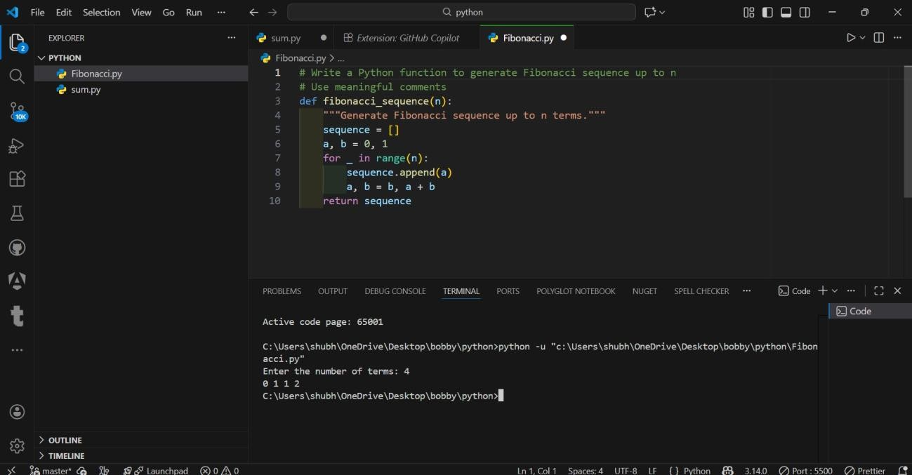
Task 4: Comparative Analysis – Procedural vs Modular Code

Criteria | Without  Functions | With  Functions
Code Clarity | Lower | Higher
Reusability | No | Yes
Debugging | Harder | Easier
Scalability | Poor | Excellent
Suitable for  Large Systems | No | Yes

Task 5: Iterative vs Recursive Fibonacci (AI-Generated):

# Generate Fibonacci using iterative approach

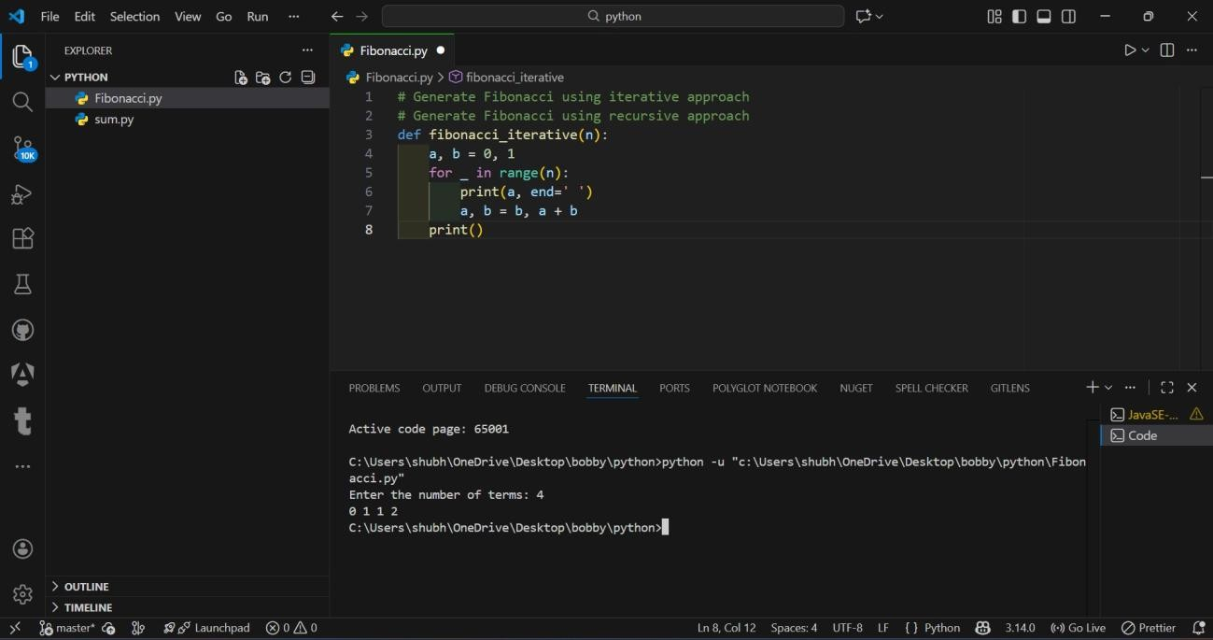

# Generate Fibonacci using recursive approach
